Enhancement:
caArray uses CSM API and UPT to provision security for their application. caArray extended CSM security to suit its needs. One of the extension is, caArray has extended “CSM Group” as “Collaboration Group” and manage it through its admin UI. caArray manages the synchronization between “CSM Group” and “Collaboration Group” through CSM APIs. caArray uses CSM UPT (User Provisioning Tool) to administer basic CSM security. By default, all features in CSM UPT are enabled for all application admin users with access to UPT. caArray has reported some cases where application admin users create “CSM Groups” through UPT that breaks the synchronization with their “Collaboration Group”. caArray requested CSM team to provide ability to disable/hide “Groups” link from UPT for all users.
Approach:
The requested enhancement is in line with CSM future enhancement consideration for customizable UPT. The future enhancement is to enable or disable selected features with in UPT to certain group, roles along with a few other requirements. In that way, caArray enhancement is a subset of CSM future enhancement. Due to time constraint, CSM 4.2.3 release would consider the enhancement to match with caArray’s requirement.
CSM is the center piece of the security provisioning process through its APIs and database schema. CSM has capability to protect “elements”, “group of elements” of an application for its users. Following is the schema to support it:
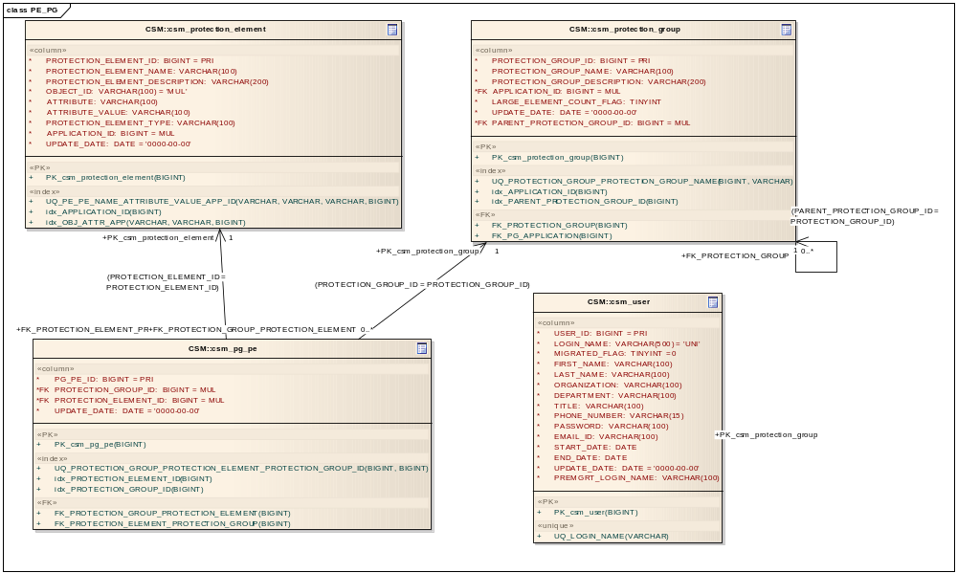
UPT is a web application to conveniently work with CSM capabilities to provision security. UPT is protected with login page so that only authenticated users are allowed to access its pages. UPT has provided this functionality by implementing CSM API. UPT is just like any other application uses CSM APIs to implement security. Based on this understanding, the approach to address caArray is as follows:
UPT application has different features with each feature attached to CSM API functionality. Each of UPT features can be looked as “protection elements”. By default, all the features of UPT are available for all admin users. By taking advantage of CSM “protection elements”, each feature with in UPT can be enabled or disabled for a particular user.
If UPT “feature” is defined as protection element for an application, that “feature” will only be visible for permitted users. If UPT “feature” is not defined as protection element for an application, it will be visible for all users. To associate UPT “feature” with “protection element”, this approach will use “protection group” as a place holder to define all main menu links as “protection groups” in CSM. Any application wishes to disable a particular link would need to create a protection element and associate that with corresponding predefined “protection group”. Application can assign a particular protection element to certain users if needed.
Following are the links identified in UPT admin application. Each of these links represent a record in CSM_PROTECTION_GROUP table.
When UPT loads its admin page, for each link defined as “protection group”, it will check for associated “protection element”. If there is no associated protection element to it, that link will be visible to all users. If there is a protection element associated, if no users are associated with that protection element, that link will disabled for all users.
Schema changes:
There is no schema change. UPT 4.2.3 will provide default schema population script with following predefined “protection groups”. UPT will also provide migration data population script from 4.2 to 4.2.3.
UPT_UI_USERS_LINK
UPT_UI_PROTECTION_ELEMENTS_LINK
UPT_UI_PRIVILEGES_LINK
UPT_UI_GROUPS_LINK
UPT_UI_PROTECTION_GROUPS_LINK
UPT_UI_ROLE_LINK
UPT_UI_INSTANCE_LEVEL_LINK

These predefined names should not be changed from the table.

caArray Use case:
- Default installation
When UPT is installed, caArray users will not see any difference in UPT features.

- Disable Group
caArray would need to do following steps to disable “Groups” link from UPT.
- Create a record in “CSM_PROTECTION_ELEMENT” table. Protection element name, description and object_Id can be filled by caArray application as they like. “APPLICATION_ID” has to be the application id from “CSM_APPLICATION” table.

Example:
INSERT INTO `csm_protection_element`
(`PROTECTION_ELEMENT_ID`, `PROTECTION_ELEMENT_NAME`, `PROTECTION_ELEMENT_DESCRIPTION`, `OBJECT_ID`, `ATTRIBUTE`,
`ATTRIBUTE_VALUE`, `PROTECTION_ELEMENT_TYPE`,
`APPLICATION_ID`, `UPDATE_DATE`)
VALUES
(100, “Group Element”, “Protection element for Group”, “Group Element”, null, null, null, 2, “2012-01-18”
);

- Create an association between above created protection element and “GROUPS” record in CSM_PROTECTION_GROUP table.
Example:
INSERT INTO `csm_pg_pe`
(`PG_PE_ID`, `PROTECTION_GROUP_ID`, `PROTECTION_ELEMENT_ID`, `UPDATE_DATE`)
VALUES
(
10, 10, 100, “2012-01-18”
);

Future Possibilities:
This proposed approach will make configurable UPT enhancement to expand disabling links in certain pages based on users, groups or roles.

